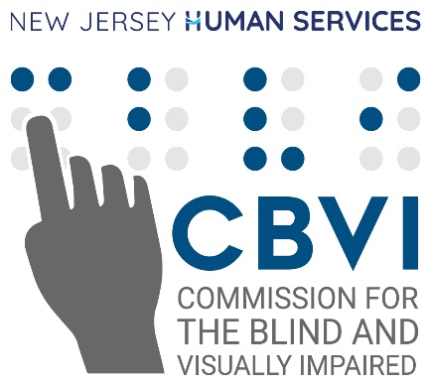
2026 - 2027 Academic Year
CBVI Board of Trustees Scholarship Application
PERSONAL:
(All fields must be completed)
Name:
Address:
City:
State:
Zip Code:
Home Phone:
Cell Phone:
E-mail:
Preferred Pronouns:
Date of Birth:
Cause of Visual Impairment:
CBVI Caseworker/Counselor’s Name:
EDUCATIONAL:
(Must be completed by current high school and college students)
Name of Current School:
City:
State:
Zip Code:
School Contact:
Title:
Phone Number:
SCHOOL YOU PLAN TO ATTEND IN FALL 2025:
(Must be completed by all applicants)
Name:
City:
State:
Zip Code:
Major Area of Study:
Degree being pursued:
Date Degree Expected (Month/Year):
FINANCIAL
(Must be completed for Bodensiek and Buckley Scholarships)
Number in Household:
Total Gross Income from All Sources:
Is this income: Yearly ☐ or Monthly ☐
ESSAY QUESTIONS
(Must be completed by all applicants)
Please answer each of the following essay questions with a minimum of 75 words and a maximum of 300 words for each response.
- Essay Question One: Who has been the most influential person in your life and why?

- Essay Question Two: What has been the most challenging aspect of your education thus far and what have you personally done to overcome that challenge?

- Essay Question Three: Why should you be selected for a scholarship? Please describe academic achievements, community service work, leadership examples, or other characteristics making you worthy of a scholarship.

- Essay Question Four: Please describe why you decided to major in one of the following areas of study: Science, Technology, Engineering, Mathematics, Business, Communications, or Health Services. (Must be completed for Bodensiek and/or Buckley Scholarships only)

Supporting documents must be submitted via email with your last name and the word “Scholarship” in the subject line.
Incomplete scholarship applications will not be considered.
Please submit your scholarship application materials on or before the deadline of April 30, 2026 to: CBVI.Scholarship@dhs.nj.gov
If you have questions or need additional information, please send an email with the word “Question” in the subject line to: CBVI.Scholarship@dhs.nj.gov.

SUBMIT APPLICATION

